Sha Tin District Tai Wai Constituency

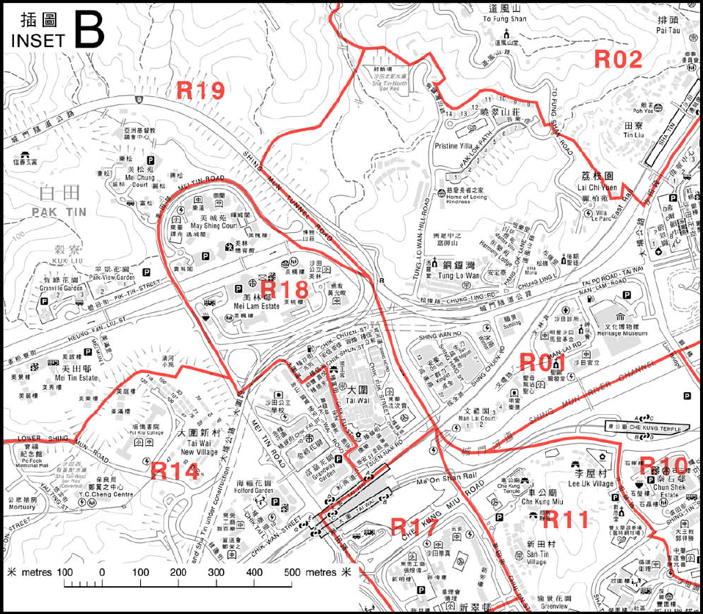

R18 is the Sha Tin District Tai Wai Constituency.
generated from the document of the Electoral Affairs Commission

